Robert Pirrie

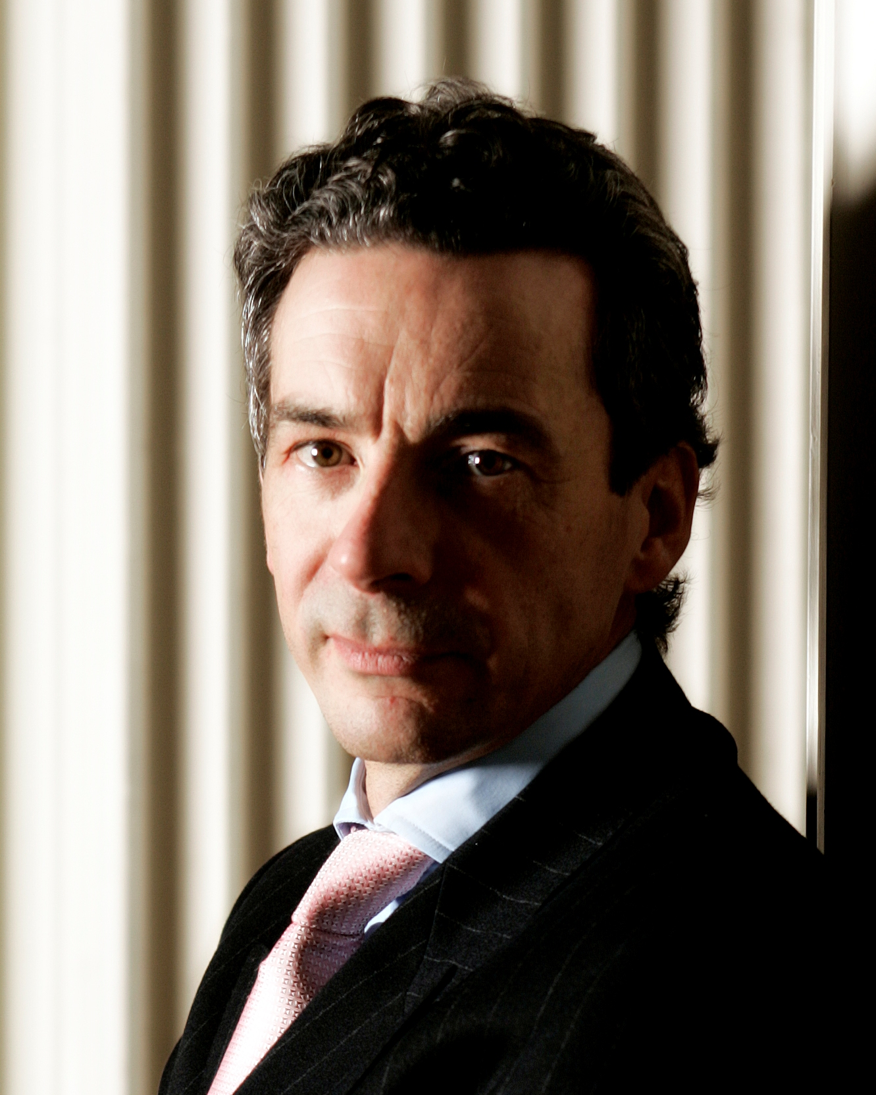
The WS Society
The Signet Library
Parliament Square
EDINBURGH
EH1 1RF
Scotland, UK

Tel: (0)131 220 3249

E-mail: rpirrie@wssociety.co.uk
Direct tel: (0)131 225 0650

Personal Assistant:
Tessa Robson
E-mail: trobson@wssociety.co.uk
Direct tel: (0)131 225 0656

Chief Executive, The WS Society

The WS Society is one of the oldest professional societies in the world. Scotland has a separate and distinctive legal system. Today the Society is an independent, non-regulatory membership body whose members are Scottish solicitors. Associate membership is available to lawyers qualified in other jurisdictions.

The existence of Scotland's law and legal system was specifically preserved under the 1707 Act of Union, the constitutional foundation of the United Kingdom. Since its inception in 1594, The WS Society has occupied a central place in the country's legal system. Associate membership is available to lawyers qualified in other jurisdictions.

Career History

An experienced corporate and commercial lawyer qualified in Scotland, UK.

- Appointed Chief Executive
2002 - 2005 Consultancy work, including tutoring and coaching in legal practice.
1997 - 2002 Partner, Dundas & Wilson (formerly part of Andersen Legal), Edinburgh, Glasgow and London. Head of Private and Equity; Head of Corporate and Commercial.
1985 - 1997 Partner, Maclay Murray & Spens, Edinburgh
1985 Admitted as Writer to the Signet
1984 - 1985 Solicitor, Maclay Murray & Spens, Glasgow
1981 - 1984 Solicitor, Moncrieff Warren Paterson, Glasgow
1981 Admitted as a Solicitor in Scotland
1980 Studying at University of British Columbia, Vancouver, Canada
1978 - 1980 Apprentice Solicitor, Mitchells Johnston Hill & Hoggan, Glasgow
1974 - 1978 LL.B (Hons - First Class), University of Glasgow

